**Set Properties and Laws by Venn Diagram**

The following are the important properties of set operations.

**(i) COMMUTATIVE PROPERTY**

(a)  A u B  =  B u A  (Set union is commutative)

(b)  A n B  =  B n A  (Set intersection is commutative)

**(ii) ASSOCIATIVE PROPERTY**

(a)  A u (B u C)  =  (A u B) u C (Set union is associative)

(b)  A n (B n C)  =  (A n B) n C (Set intersection is associative)

**(iii) DISTRIBUTIVE PROPERTY**

(a)  A n (B u C)  =  (A n B) u (A n C) (Intersection distributes over union)

(b)  A u (B n C)  =  (A u B) n (A u C) (Union distributes over intersection)

**De Morgan’s law for set difference:**

For any three sets A, B and C, we have

**(i)  A \ (B u C)  =  (A \ B) n (A \ C)**

**(ii)  A \ (B n C)  =  (A \ B) u (A \ C)**

**De Morgan’s law for set complementation:**

Let U be the universal set containing sets A and B. Then

**(i)  (A u B)'  =  A' n B'**

**(ii)  (A n B)'  =  A' u B'**

**Proof by Venn diagram - Properties of set operations**

**Problem 1**

For the given sets A = { -10, 0, 1, 9, 2, 4, 5 } and B = {-1, -2, 5, 6, 2, 3, 4 }, verify that

(i) Set union is commutative. Also verify it by using Venn diagram.

(ii) Set intersection is commutative. Also verify it by using Venn diagram.

**Solution :**

(i) Let us verify that union is commutative.

A u B  =  { -10, 0, 1, 9, 2, 4, 5 } u {-1, -2, 5, 6, 2, 3, 4 }

A u B  =  { -10, -2, -1, 0, 1, 2, 3, 4, 5, 6, 9 } ---------(1)

B u A  =  {-1, -2, 5, 6, 2, 3, 4 } u { -10, 0, 1, 9, 2, 4, 5 }

B u A  =  { -10, -2, -1, 0, 1, 2, 3, 4, 5, 6, 9 } ---------(2)

From (1) and (2), we have

A u B  =  B u A

By Venn diagram, we have

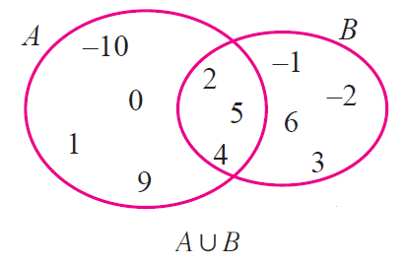

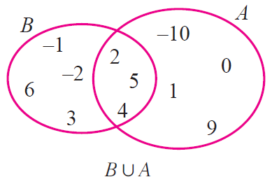

From the above two Venn diagrams, it is clear that  A u B  =  B u A

Hence, it is verified that set union is commutative.

(ii) Let us verify that intersection is commutative.

A n B  =  { -10, 0, 1, 9, 2, 4, 5 } n {-1, -2, 5, 6, 2, 3, 4 }

A n B  =  { 2, 4, 5 } ---------(1)

B n A  =  {-1, -2, 5, 6, 2, 3, 4 } u { -10, 0, 1, 9, 2, 4, 5 }

B n A  =  { 2, 4, 5 } ---------(2)

From (1) and (2), we have

A n B  =  B n A

By Venn diagram, we have

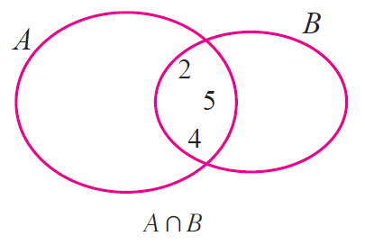

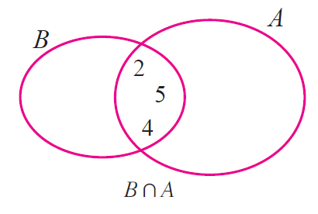

From the above two Venn diagrams, it is clear that

A n B  =  B n A

Hence, it is verified that set intersection is commutative.

**Problem 2**

For the given sets A = { 1, 2, 3, 4, 5 }, B = { 3, 4, 5, 6 } and C = { 5, 6, 7, 8 }, verify that A u (B u C )  =  (A u B) u C. Also verify it by using Venn diagram.

**Solution:**

Let us verify that set union is associative.

B u C  =  { 3, 4, 5, 6 } u { 5, 6, 7, 8 }

B u C  =  { 3, 4, 5, 6, 7, 8 }

A u (B u C)  =  { 1, 2, 3, 4, 5 } u { 3, 4, 5, 6, 7, 8 }

A u (B u C)  =  { 1, 2, 3, 4, 5, 6, 7, 8 } ---------(1)

A u B  =  { 1, 2, 3, 4, 5 } u { 3, 4, 5, 6 }

A u B  =  { 1, 2, 3, 4, 5, 6 }

(A u B) u C  =  { 1, 2, 3, 4, 5, 6 } u { 5, 6, 7, 8 }

(A u B) u C  =  { 1, 2, 3, 4, 5, 6, 7, 8 } ---------(2)

From (1) and (2), we have

A u (B u C)  =  (A u B) u C

By Venn diagram, we have

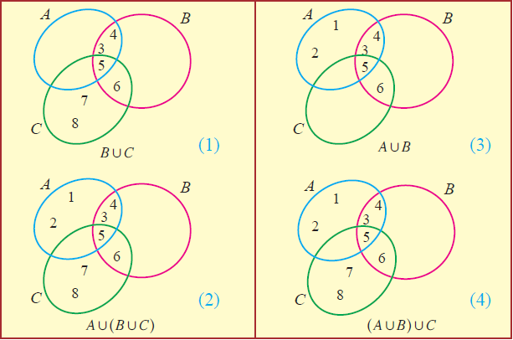

From the above Venn diagrams (2) and (4), it is clear that

A u (B u C)  =  (A u B) u C

Hence, it is verified that set union is associative.

**Problem 3**

For the given sets A = { a, b, c, d }, B = { a, c, e } and C = { a, e }, verify that A n (B n C)  =  (A n B) n C. Also verify it by using Venn diagram.

**Solution :**

Let us verify that set intersection is associative.

B n C  =  { a, c, e } u { a, e }

B n C  =  { a, e }

A n (B n C)  =  { a, b, c, d } n { a, e }

A n (B n C)  =  { a } ---------(1)

A n B  =  { a, b, c, d } u { a, c, e }

A n B  =  { a, c }

(A n B) n C  =  { a, c } n { a, e }

(A n B) n C  =  { a } ---------(2)

From (1) and (2), we have

A n (B n C)  =  (A n B) n C

By Venn diagram, we have

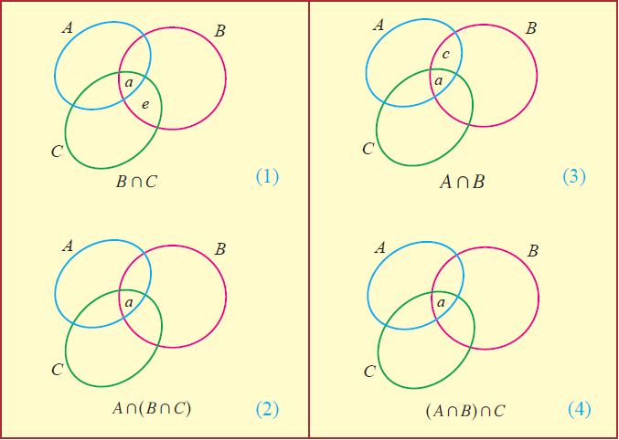

From the above Venn diagrams (2) and (4), it is clear that

A n (B n C)  =  (A n B) n C

Hence, it is verified that set intersection is associative.

**Problem 4**

For the given sets A = { 0, 1, 2, 3, 4 }, B = { 1, -2, 3, 4, 5, 6 } and C = { 2, 4, 6, 7 }, verify that A u (B n C )  =  (A u B) n (A u C). Also verify it by using Venn diagram.

**Solution**

Let us verify that union distributes over intersection.

B n C  =  { 1, -2, 3, 4, 5, 6 } n { 2, 4, 6, 7 }

B n C  =  { 4, 6 }

A u (B n C)  =  { 0, 1, 2, 3, 4 } u { 4, 6 }

A u (B n C)  =  { 0, 1, 2, 3, 4, 6 } ---------(1)

A u B  =  { 0, 1, 2, 3, 4 } u { 1, -2, 3, 4, 5, 6 }

A u B  =  { -2, 0, 1, 2, 3, 4, 5, 6 }

A u C  =  { 0, 1, 2, 3, 4 } u { 2, 4, 6, 7 }

A u C  =  { 0, 1, 2, 3, 4, 6, 7 }

(A u B) n (A u C)  =  { -2, 0, 1, 2, 3, 4, 5, 6 } n { 0, 1, 2, 3, 4, 6, 7 }

(A u B) n (A u C)  =  { 0, 1, 2, 3, 4, 6 } ---------(2)

From (1) and (2), we have

A u (B n C)  =  (A u B) n (A u C)

By Venn diagram, we have

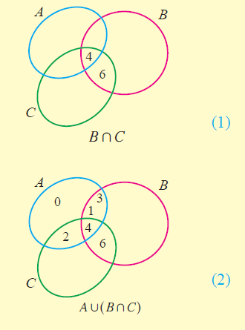

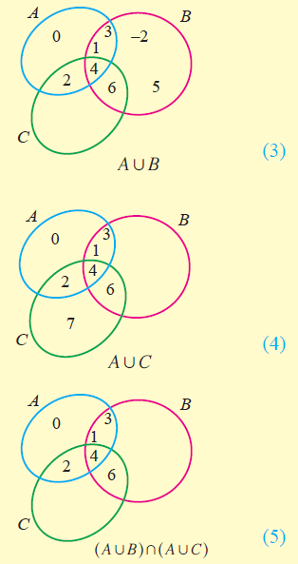

From the above Venn diagrams (2) and (5), it is clear that

A u (B n C)  =  (A u B) n (A u C)

Hence, it is verified that union distributes over intersection.

**De Morgan's laws**

**A \ (B n C)  =  (A \ B) u (A \ C)**

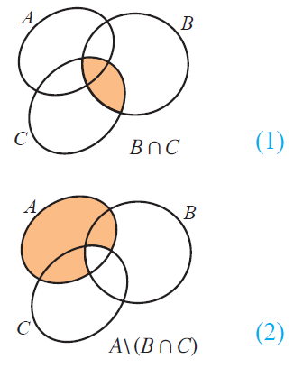

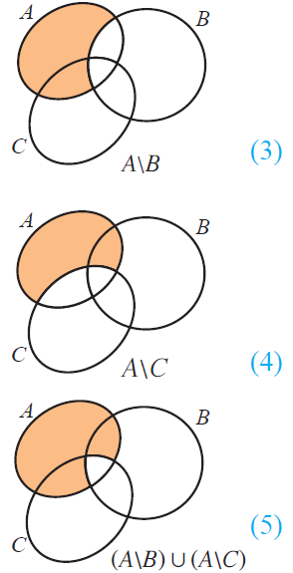

From the above Venn diagrams (2) and (5), it is clear that

A \ (B n C)  =  (A \ B) u (A \ C)

Hence, De morgan's law for set difference is verified.

Now, let us look at the Venn diagram proof of De morgan's law for complementation.

**(A n B)'  =  A' u B'**

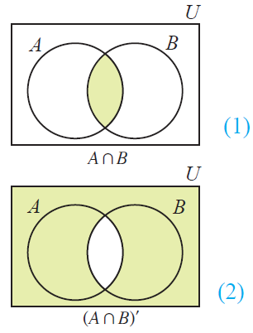

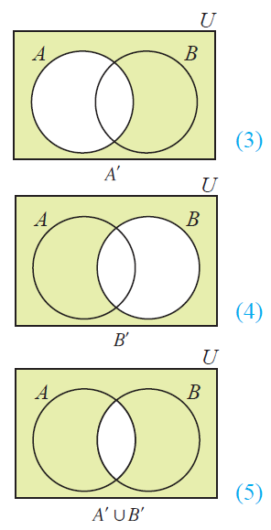

From the above Venn diagrams (2) and (5), it is clear that

(A n B)'  =  A' u B'

Hence, De Morgan’s law for complementation is verified.